**Portfolio 5**

**Part 1 – Merging**

**Introduction**

Version Control System (VCS) are used by developers when they create something such as applications and other things, they constantly make changes to the code and release a new version. These systems allow these changes, store the modifications in a central repository, helping developers to easily collaborate by downloading the latest version, making changes and upload the newest version and repeat.

However, it is impossible for more than 1 person to concurrently develop the application due to the codes a person downloaded may not be the most recent one because someone else modified it and uploaded it while he was working on the codes. This will create inconsistencies to the modification of the program and may lose the changes made.

**Branch**

This is why branching is a necessity in this system. Branching is when you diverge from the main line of development and continue to do work without messing with that main line. This is a somewhat expensive process, often requiring you to create a new copy of your source code directory, which can take a long time for large projects.

In Git however, the branching is lightweight and fast. This is because Git encourages workflow that branch and merge often. To go more in-depth on Git branches, the git branch command lets you create, list, rename, and delete branches. New commits are recorded in the history for the current branch, which results in a fork in the history of the project. Branches makes sure that unstable code is never committed to the main code base, and it gives you the chance to clean up your feature’s history before merging it into the main branch.

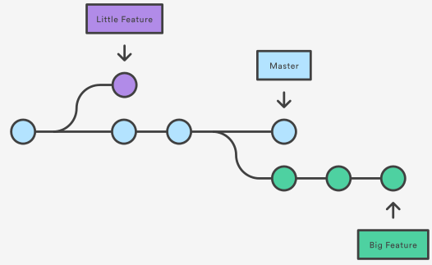

In the diagram above a repository with two branches, one for a little feature, and one for a longer-running feature. By developing them in branches, it is possible to work on both of them in concurrently, but it also keeps the master branch away from questionable codes.

**Git Checkout**

git checkout is basically a command to switch to an existing branch or the master branch. This is used hand-in-hand with git merge <branch name> which merges the specified branch into the current branch.

**Conflicts**

If the two branches to be merged changes the same part of the same file, Git will not be able to figure out which version to use. When this happens, it stops right before the merge commit for the conflict to be resolved manually.

**Conclusion**

Merging is an important feature in VCS for developing any program due to its management of versions as well as having alternative version for testing and developing a new function before implementing it into the main program. It also allows multiple developer to concurrently work on the same program for greater efficiency.